Lab 2
Combinational Circuit Design
using Gate-Level Modeling and
Synthesis on FPGA

made by
Hanan Alosaimi
shahd Abdullah

repo link:
https://github.com/hanan0101/Repo_Lab2_DCD_SH.git
Note: in task3 there is all tasks from task2 to task5

TASK 1 : 4-input AND gate Implementation on FPGA:

case: a=1 ,b=1 : f=1

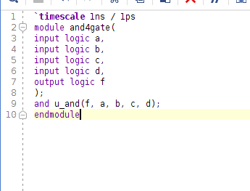

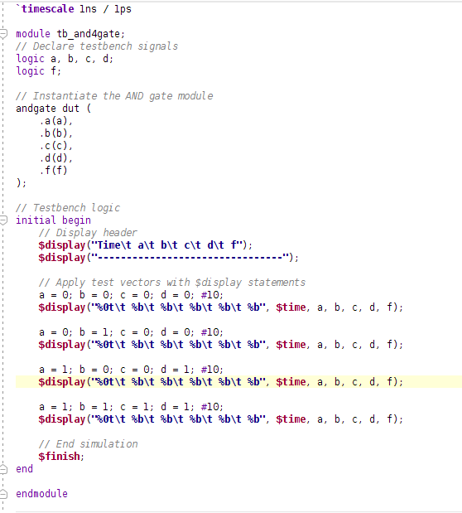

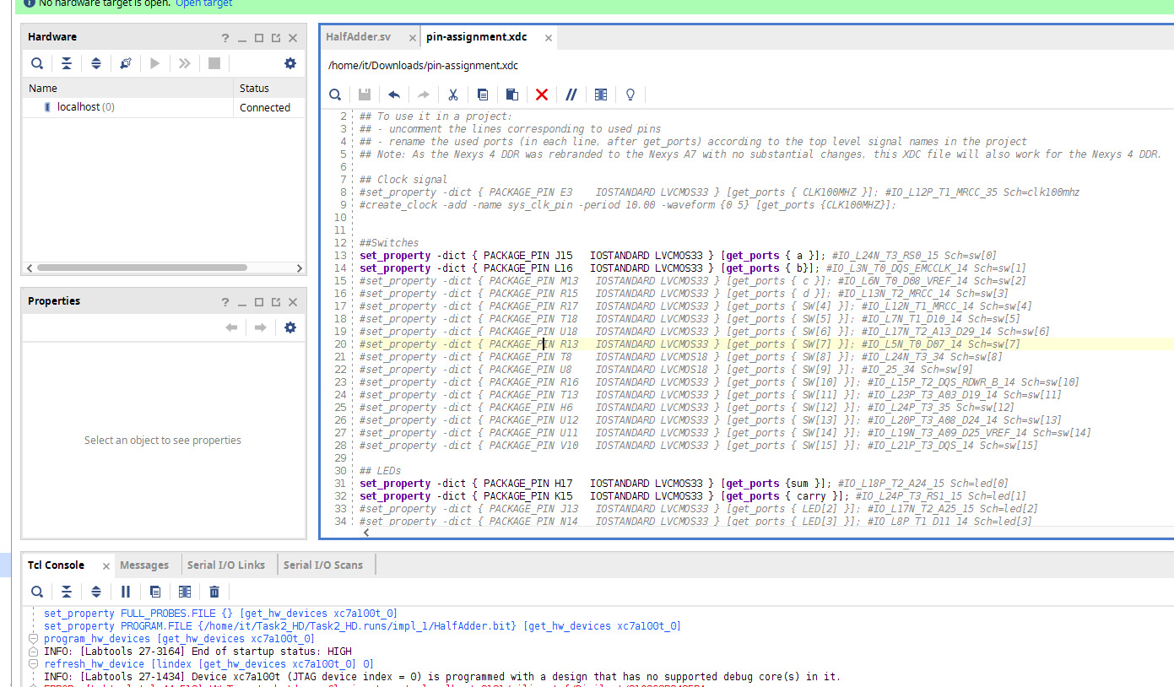
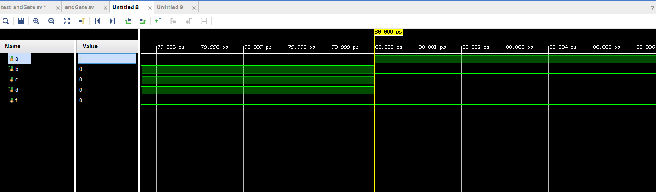

implement a 4-input AND gate on the FPGA.

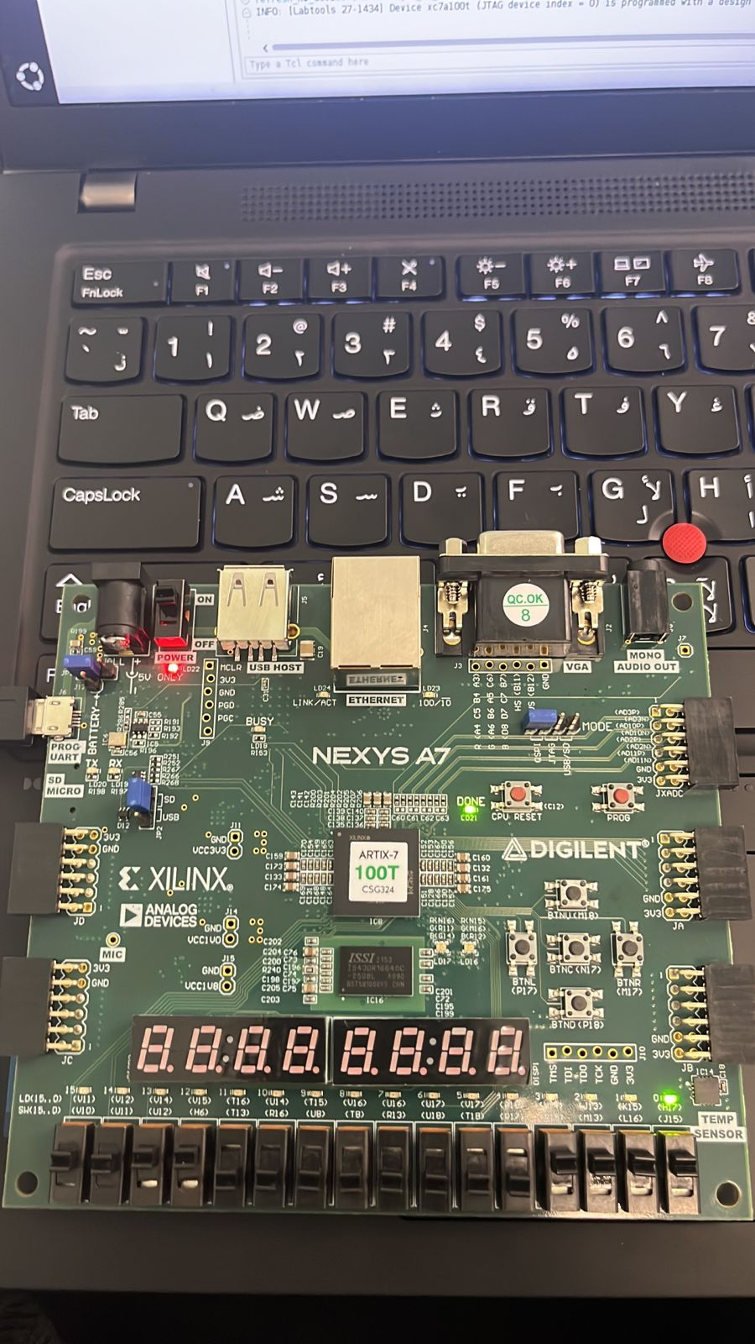
case: a=1 ,b=1 : f=1

Note:we showed qumar other case

TASK 2 : Half Adder Implementation on FPGA:
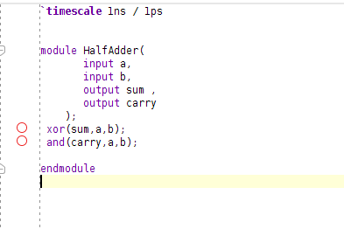

Simulation results:

timescale 1ns / 1ps

module test_HD;
logic a, b, sum ,carry;

//inctsance
HalfAdder hd(a,b,sum,carry);

initial begin

// Display header
$display("Time\t a b sum, carry");

a = 0; b = 0; ; #10;
// Display the value of a, b, c, and d along with time
$display("%0t\t %b\t %b\t %b %b", $time, a, b, sum ,carry);
#3
a = 1; b = 0; ; #10;

$display("%0t\t %b\t %b\t %b %b", $time, a, b, sum ,carry);
#5
a = 0; b = 1; ; #10;

$display("%0t\t %b\t %b\t %b %b", $time, a, b, sum ,carry);
a = 1; b = 1; ; #10;
#7
$display("%0t\t %b\t %b\t %b %b", $time, a, b, sum ,carry);

$finish;
end
endmodule

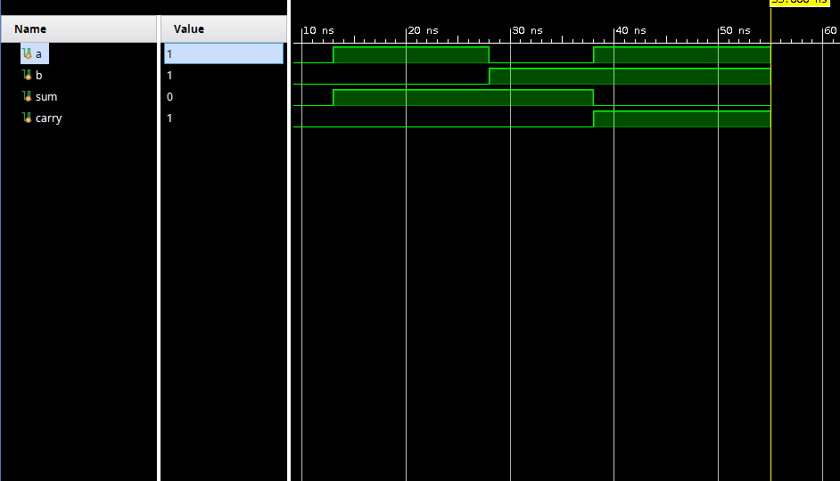

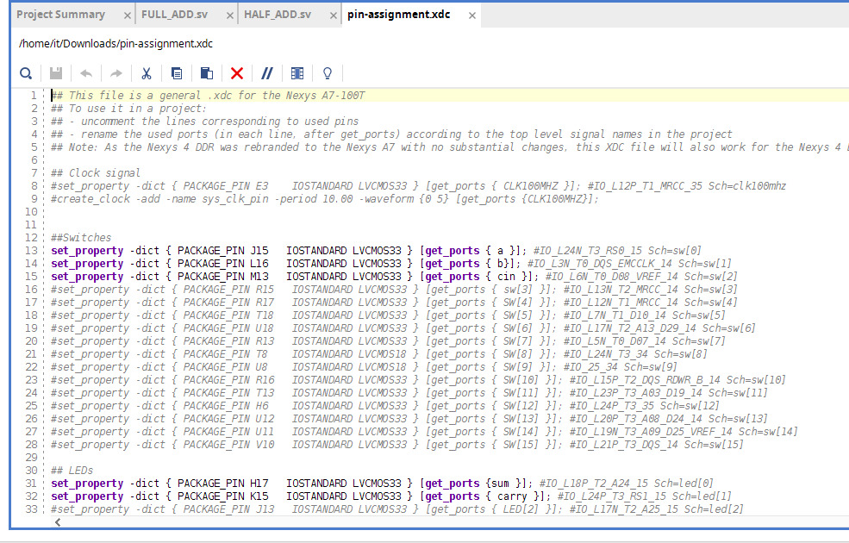

implement a Half Adder on the FPGA.

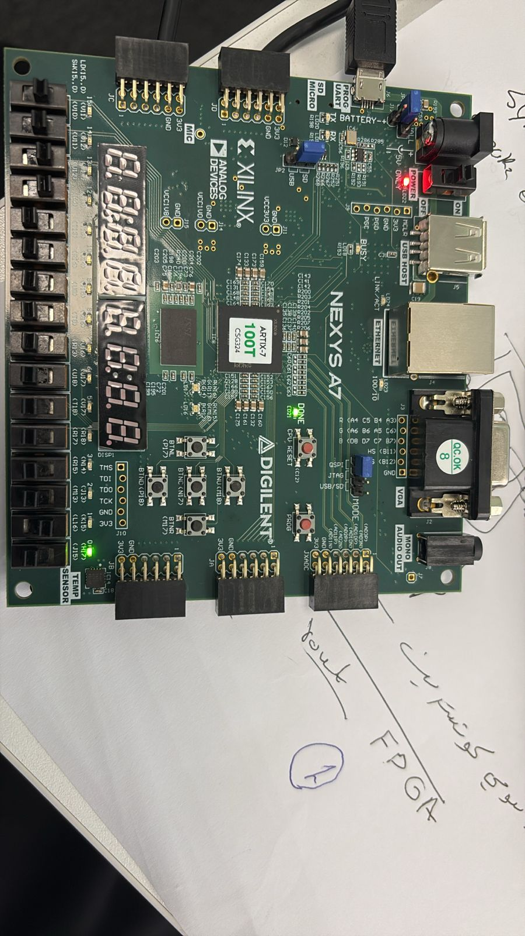
Case : a=0, b=0 ,sum =1 ,carry =0

Note :other case we showed Qumer .

TASK 3 : Full Adder Implementation on FPGA

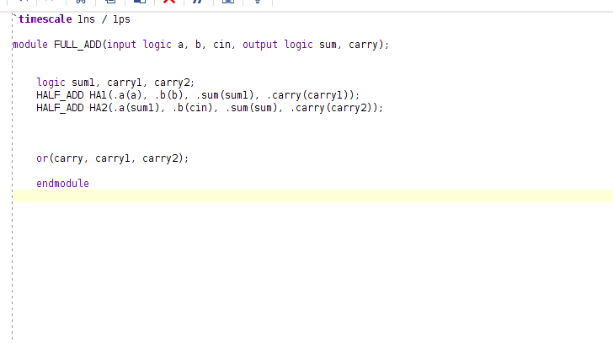

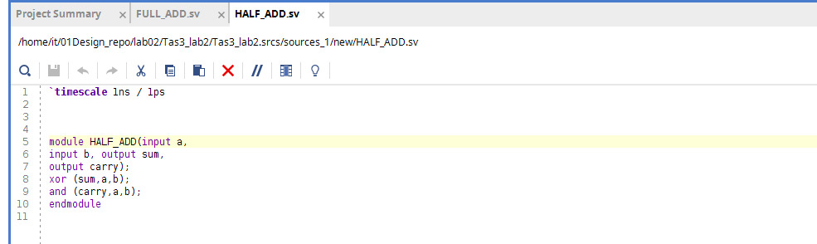

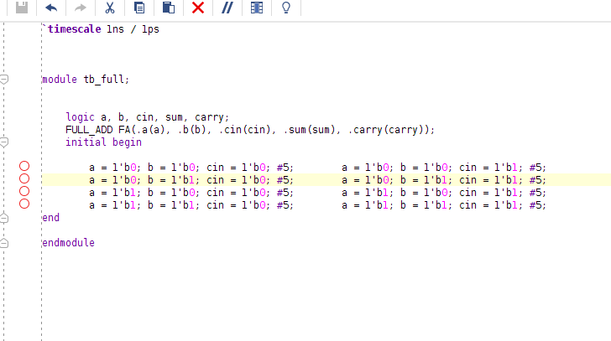

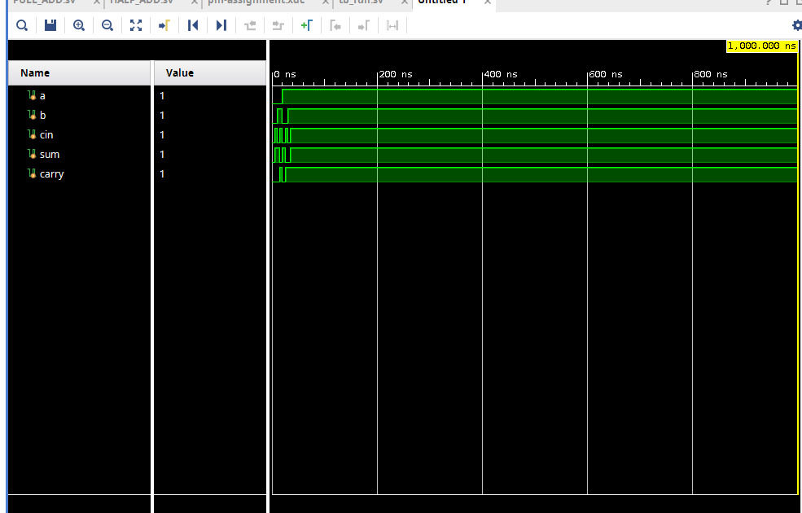

TASK 4 : 4 bit Adder:

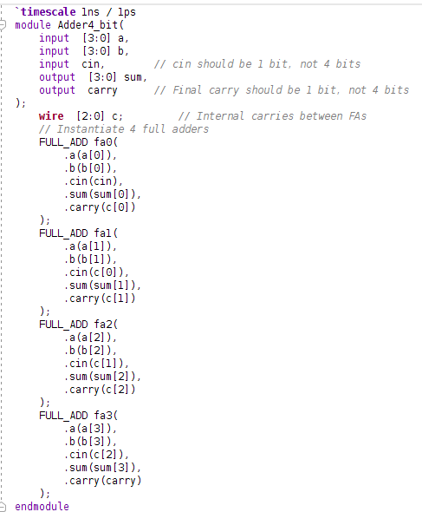

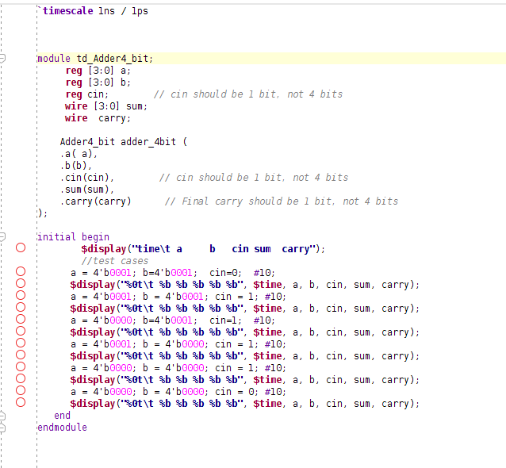

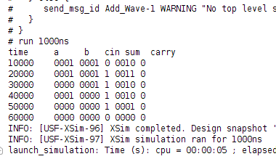

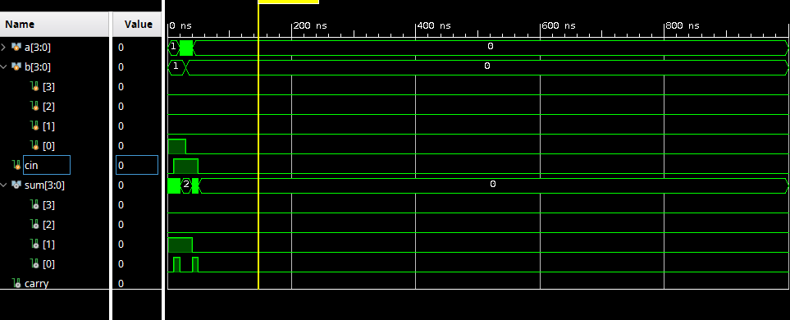
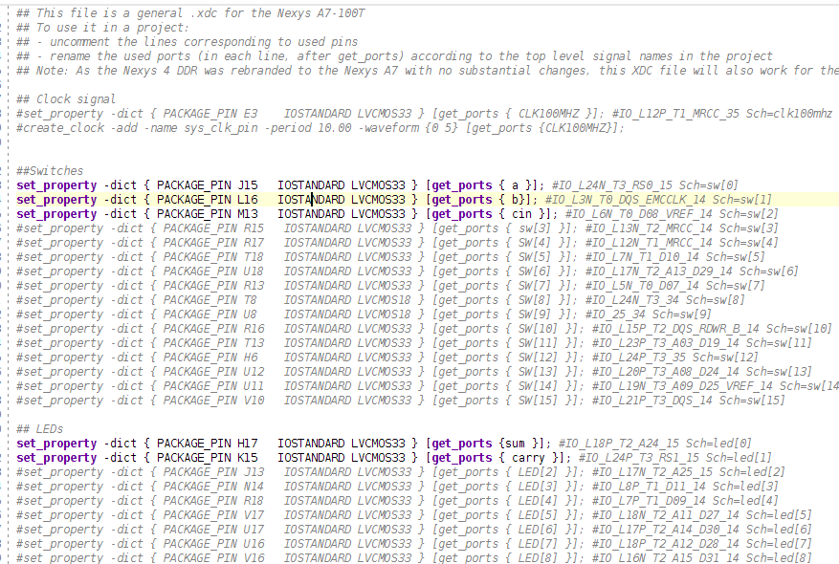

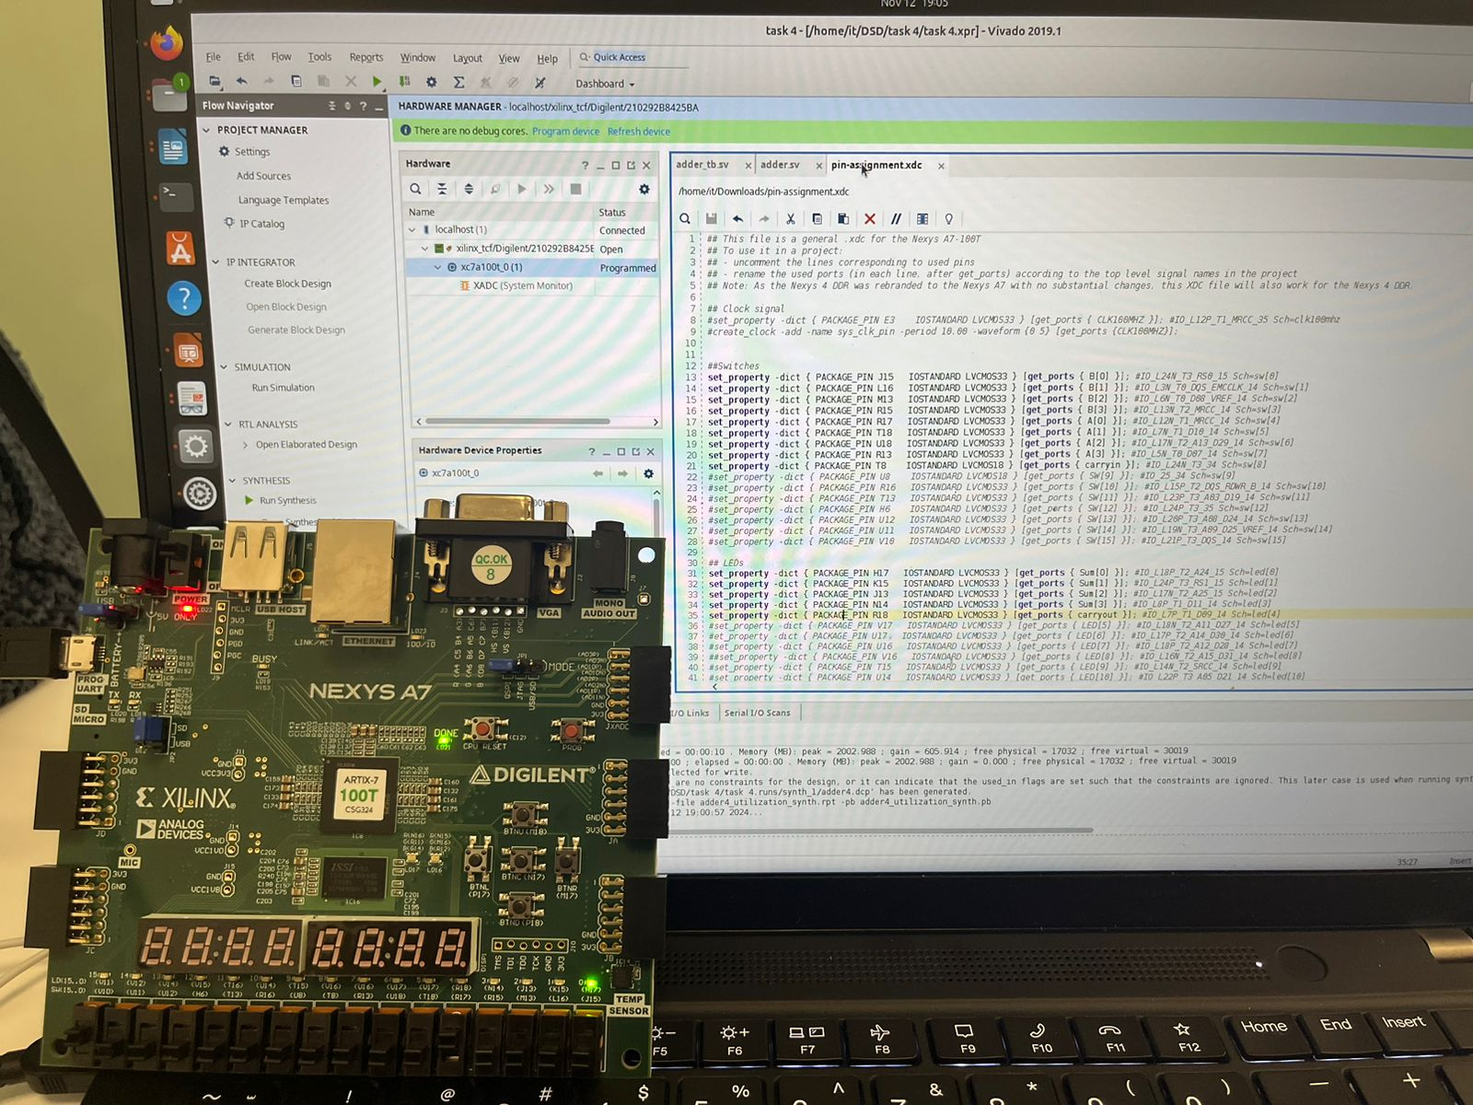

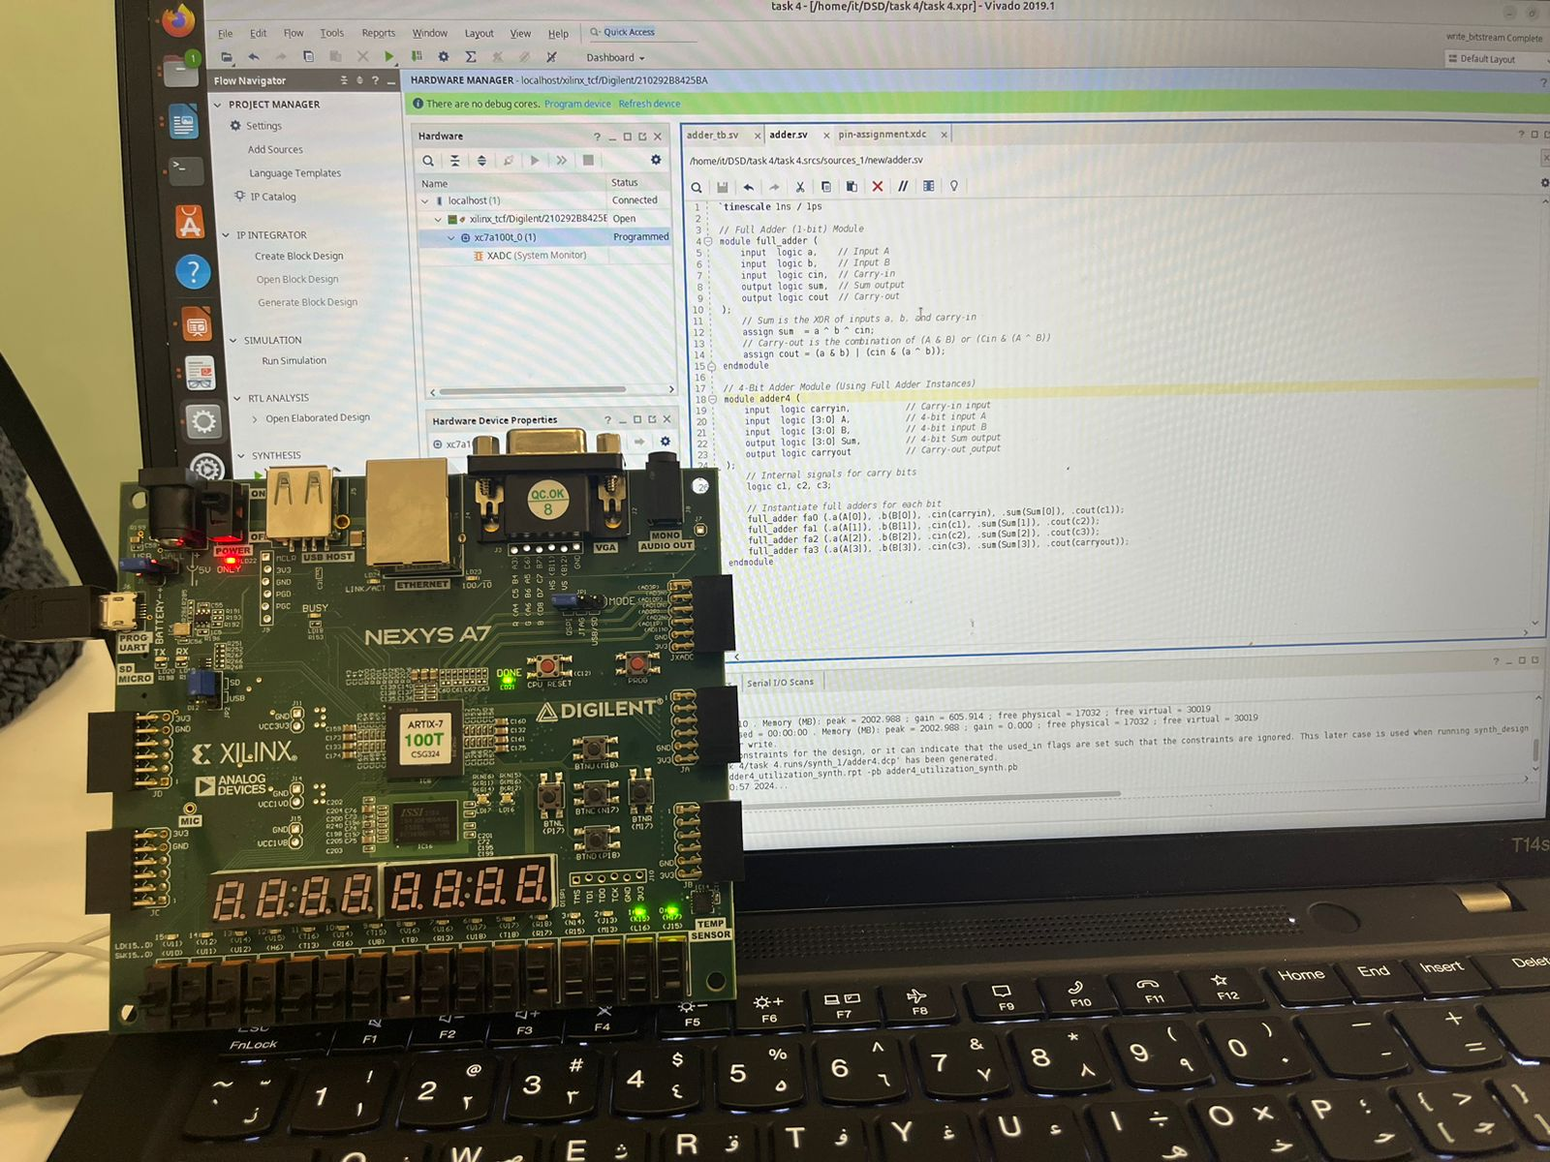

Task5:

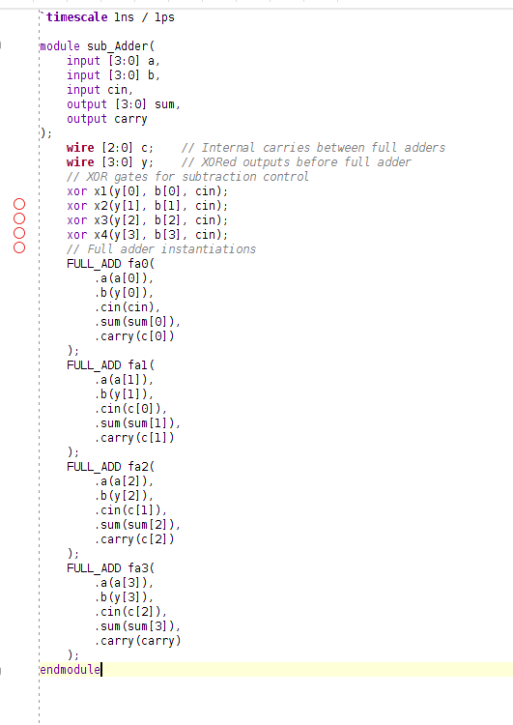

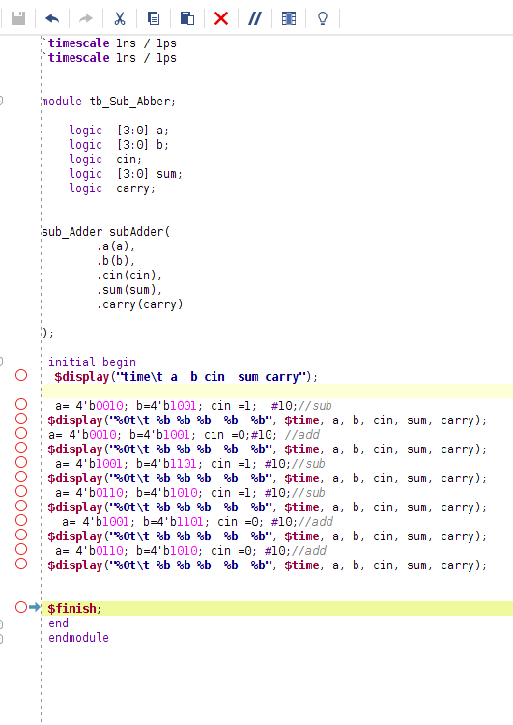

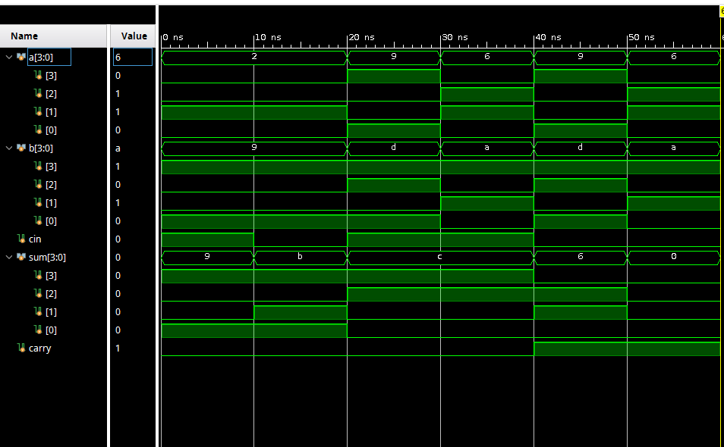
The output:



